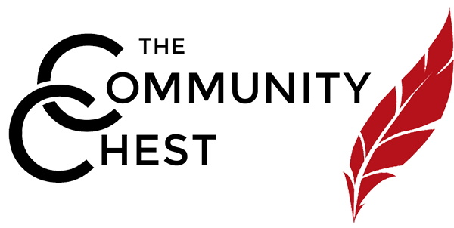
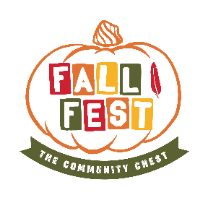
Live Auction Donation
Fall Fest
October 23, 2019
Englewood Field Club
341 Engle Street, Englewood, NJ 07631
6:30 pm – 9:30 pm
Item: _________________________________________________________________________
Retail Value: ___________________________________________________________________
Donor Name (to appear in catalog):
________________________________________________
Address: ______________________________________________________________________
City, State, Zip: _________________________________________________________________
Contact: ______________________________________________________________________
Phone: _______________________________________________________________________
Email: ________________________________________________________________________
Description of item for catalog:
________________________________________________________________________________ ______________________________________________________________________________
Item Exchangeable? _____ Donor Anonymous ____
Comments or restrictions? ________________________________________________________
Submit completed form to:
sandyp@thecommunitychestofenglewood.org or shelly@communitychestofenglewood.org Mail to: The Community Chest, 122 S. Van Brunt Street, Englewood, NJ 07631 Phone: (201) 568-7474. Your donation becomes the property of The Community Chest and is tax deductible to the full extent of the law. Please refer to section 501 (c) (3) of the Internal Revenue Code in publication #526 regarding non-cash charitable contributions.

